In control systems, a controller corrects the output of a particular system to a desired input in the presence of errors and disturbances. The most popular type of controller is **PID**which is an acronym for **P**roportional, **I**ntegral and **D**erivative. In this Arduino PID control tutorial, I will show you how you can employ such a controller in your project.

**What is PID?**

As mentioned, PID is short for proportional, integral and derivative. The name comes from the methods on how such controller deals with disturbances in the system. However, such a controller is only in **feedback systems**. I suggest reading specifically written for such topic, but I’ll do my best to explain it here as simple as I can.

A feedback system is a system wherein part of the output is “fed back” to the input. For example, you could have a project that controls the fire in the furnace. Below is a simple illustration:

[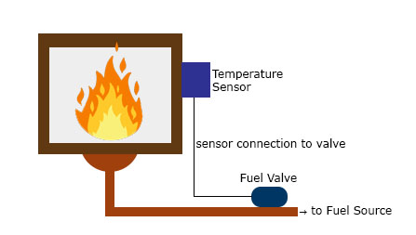](https://i1.wp.com/www.teachmemicro.com/wp-content/uploads/2019/01/temperature-control-pid.jpg?ssl=1)

You want to maintain the temperature in the furnace to a certain **set point**.  A sensor installed in the furnace determines the temperature at any time. This sensor, in this case, provides the feedback as a reference on the required temperature increase or decrease. The difference between the feedback sensor value and a temperature set point is the **error.**

**Proportional Control**

**Proportional control** refers to an adjustment that is proportional to how much the error is. Let’s say the controller in our example is an electronic valve for controlling the fuel to the furnace. If the error is small, the valve will release a small amount of fuel so that the set point and the feedback matches. If the error is large, the valve must release more fuel.

**Integral Control**

Proportional control produces **offset** in its correction due to disturbances. The **Integral controller** has the ability to remove this offset and bring back the error to zero. Such controller produces an adjustment that is based on the accumulated error over time. Without integral control, the system can’t deal with *trends* on errors.

Using our previous example, an offset may be present when the fuel valve didn’t return to its original position when it *increased then decreased* its fuel output. The integral controller will detect this, and will turn the fuel valve to its original position.

**Derivative Control**

Finally, **Derivative control** deals with the *rate of change of the error*. If integral control looks at the history of the error, derivative control predicts the error. Basically, the amount of correction will be based on how fast the error is changing. This type of controller works best with dynamic errors in which both proportional and integral controllers can’t deal with.

Let’s say the temperature in the furnace goes from 130 °C to 140 °C against a 120 °C set point in 2 seconds. The proportional and integral controllers will respond to the magnitude of the error, but it will have a hard time catching up to how fast the error occurred.. The derivative controller can deal with such because it has been looking at the rate of change of the error from the beginning.

A feedback system with a PID controller:

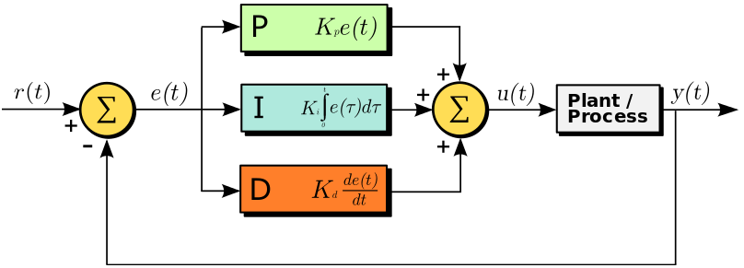

Here the input variable or set point is *r(t)*, output variable is *y(t)*, controlled variable is *u(t)* and the error is *e(t)*. Continuing with our furnace example, r(t) would be the desired temperature and y(t) is the actual temperature; e(t) is the difference between the desired temperature and actual temperature; u(t) is the sum of the corrections from the P, I and D controllers which is fed to the plant which is the fuel valve.

Note that a PID controller is not usable out of the box. **Tuning** must be done to ensure that the desired performance is achieved. This is done by carefully changing **K constants** as shown on the diagram above. These constants must be determined beforehand and changed according to the actual response of the system until the optimum values are achieved.

**Implementing PID in Code**

To implement a PID controller in a code or an Arduino sketch, five parameters must be known: *proportional, integral and derivative constants, input value and set point value*.

PID computation must be inside a looping function. The first part of the function should be determining the time elapsed. In Arduino, the current time can be determined by *millis()* and the elapsed time is just:

|  |  |
| --- | --- |
| 1  2 | currentTime = millis();  elapsedTime = currentTime - previousTime; |

Next, the error must be determined:

|  |  |
| --- | --- |
| 1 | error = setPoint - input; |

Recall that the integral of the error is the cumulative error over time.

|  |  |
| --- | --- |
| 1 | cumError += error * elapsedTime; |

The derivative of the error is the rate of change of the error:

|  |  |
| --- | --- |
| 1 | rateError = (error - lastError)/elapsedTime; |

Finally, the computed output is:

|  |  |
| --- | --- |
| 1 | output = Kp * error + Ki * cumError + Kd * rateError; |

Here, the Kp, Ki and Kd are the predetermined constants.

Finally, the variables must be noted for the next iteration:

|  |  |
| --- | --- |
| 1  2 | lastError = error;  previousTime = currentTime; |

Let’s try a more concrete example. Imagine a wheel attached to a motor. We want the wheel to remain in the position shown:

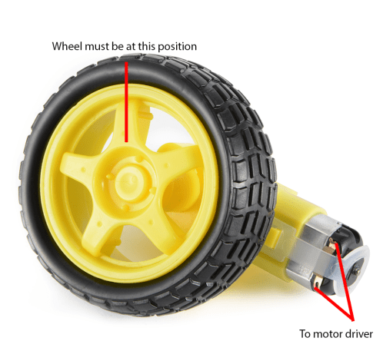

A *rotary encoder* on the wheel gives the angle in degrees of the current wheel position. At our desired wheel position, the angle is zero.

What we want is for the motor to turn whenever the wheel is out of position. Furthermore, the motor is controlled through pulse width modulation. The wider the pulse, the farther the motor rotates.

In the loop function, the rotary encoder determines the current position of the wheel and its output value becomes a parameter for the *computePID()* function. This function returns a value for controlling the motor using PWM.

**Arduino PID Library**

We can further simplify the use of PID in Arduino projects with the help of [Brett Beauregard’s PID library](https://github.com/br3ttb/Arduino-PID-Library) . The library only requires you to specify kd, ki, kp and setpoint values and you’re good to go!